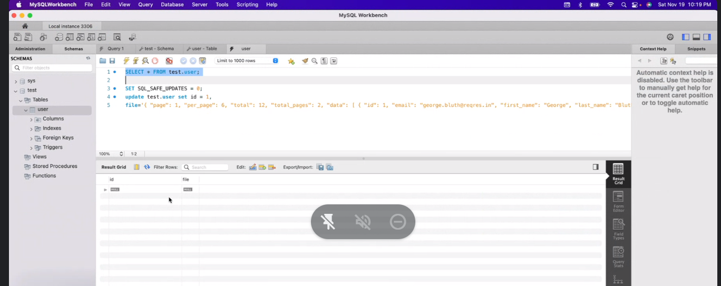

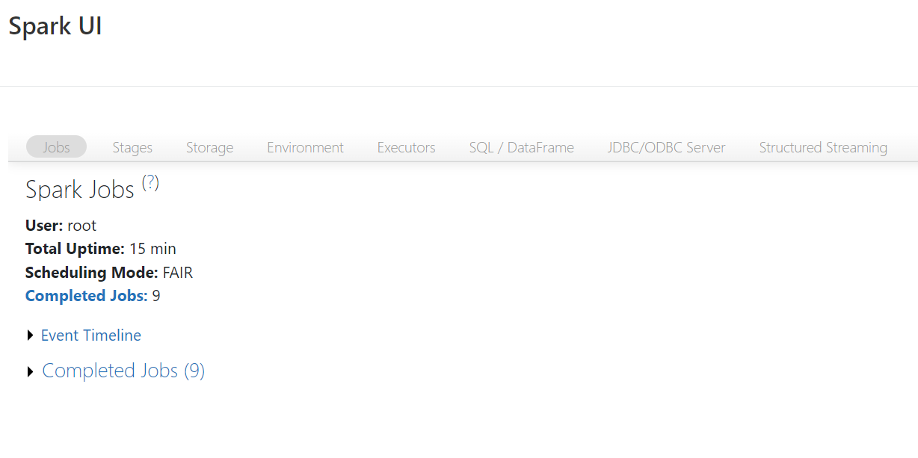

RESTORE TABLE yourTblName TO VERSION AS OF 7

select \* from yourTblName Version as of 7

To get previous version , you can do few steps, as:

SELECT max(version) -1 as previousVersion FROM (DESCRIBE HISTORY yourTblName)

You can find History of delta table by using:

DESCRIBE HISTORY yourTblName

Next, we can run the following OPTIMZE combined with Z-ORDER command on the column that we want to filter, which is DayofMonth. Note that Z-Order optimizations work best on columns that have high cardinality.

Based on the results, 2308 files were removed and 300 files were added as part of the Z-ORDER OPTIMIZE process.

%sql

OPTIMIZE flights ZORDER BY (DayofMonth)

